**Output**

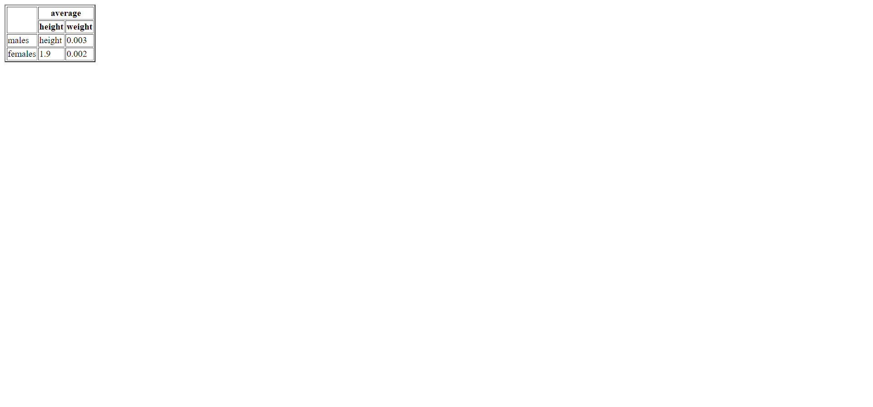

**Program – 1**

**Aim:-**

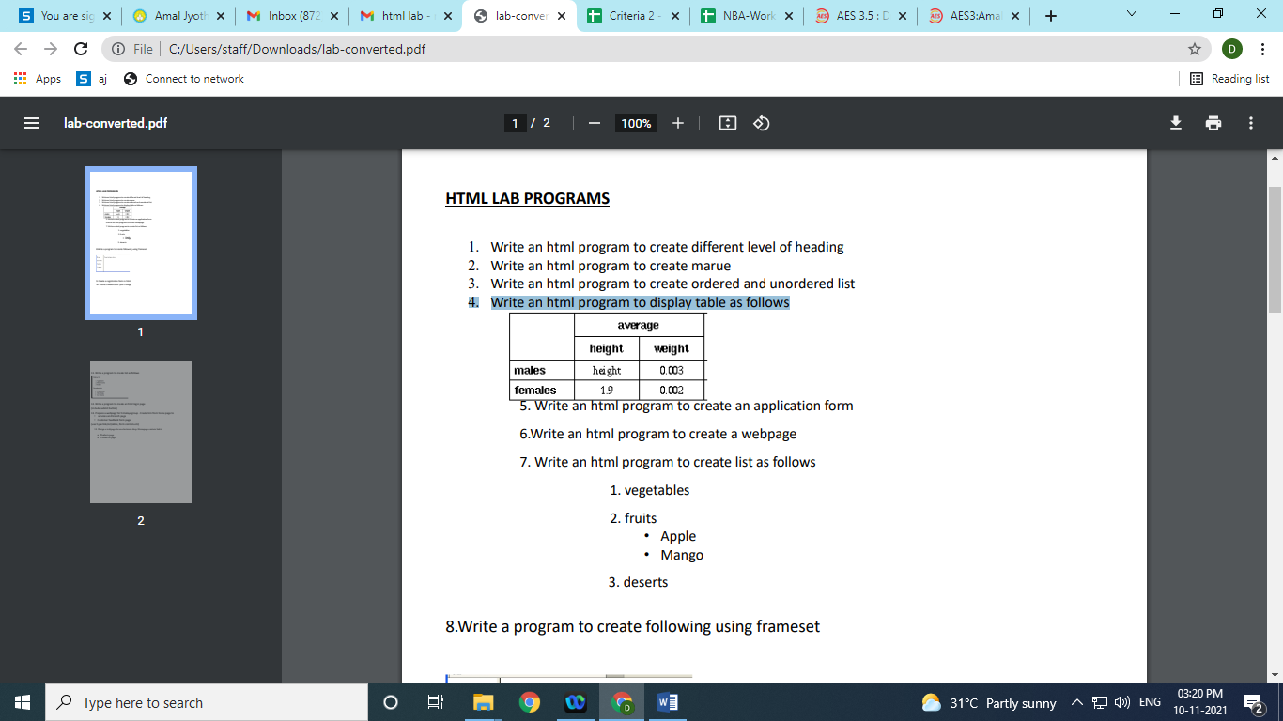Write an html program to display table as follows

**Program code**

<html>

<body>

<table border="2">

<tr>

<th rowspan="2"></th>

<th colspan="2">average</th>

</tr>

<tr>

<th>height</th>

<th>weight</th>

</tr>

<tr>

<td>males</td>

<td>height</td>

<td>0.003</td>

</tr>

<tr>

<td>females</td>

<td>1.9</td>

<td>0.002</td>

</tr>

</table>

</body>

</html>

**Output**

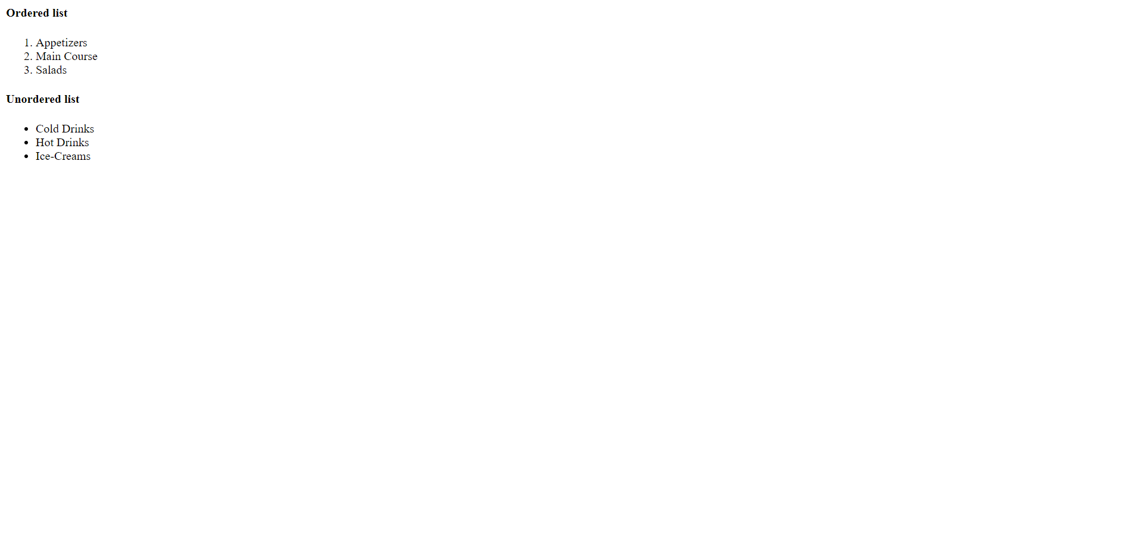

**Program – 2**

**Aim:-**

Write a program to create list as follows

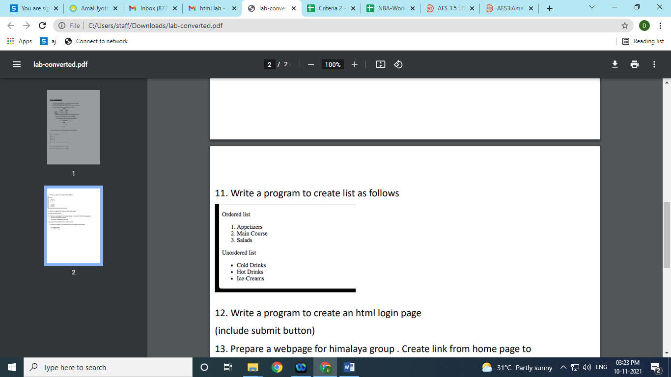

**Program code**

<html>

<body>

<h4>Ordered list</h4>

<ol>

<li>Appetizers</li>

<li>Main Course</li>

<li>Salads</li>

</ol>

<h4>Unordered list</h4>

<ul>

<li>Cold Drinks</li>

<li>Hot Drinks</li>

<li>Ice-Creams</li>

</ul>

</body>

</html>

**Output**

index page

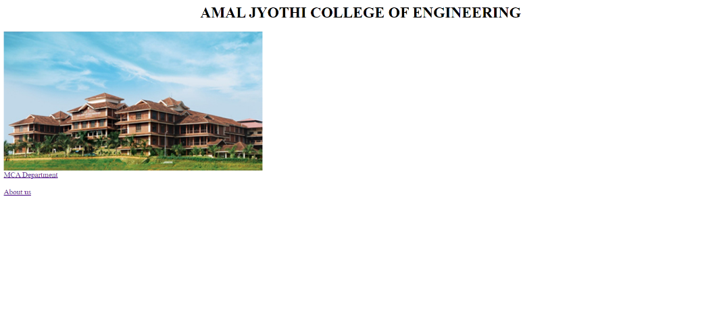

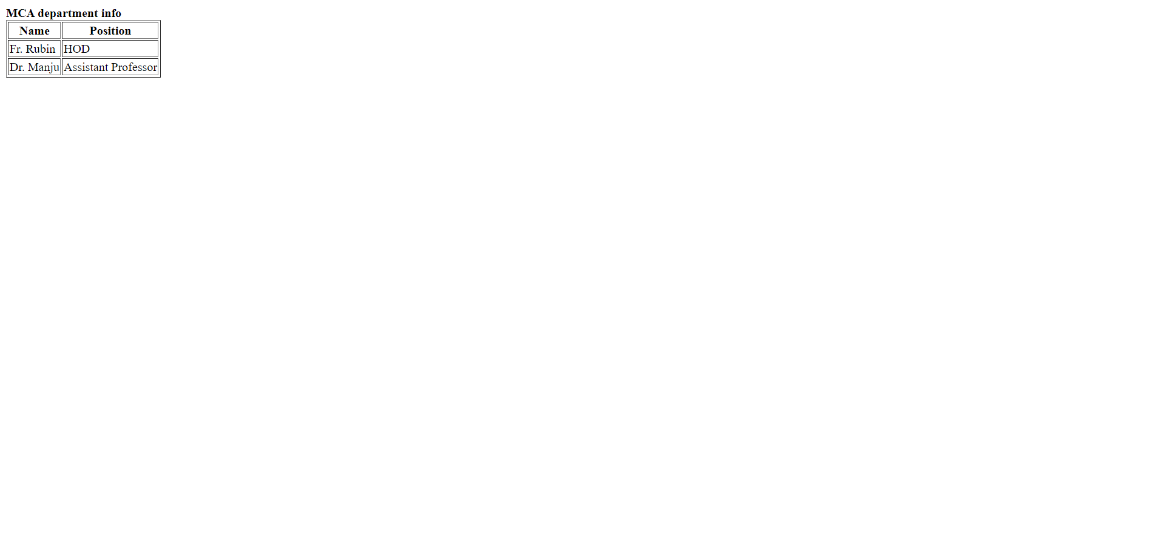MCA Department

About us

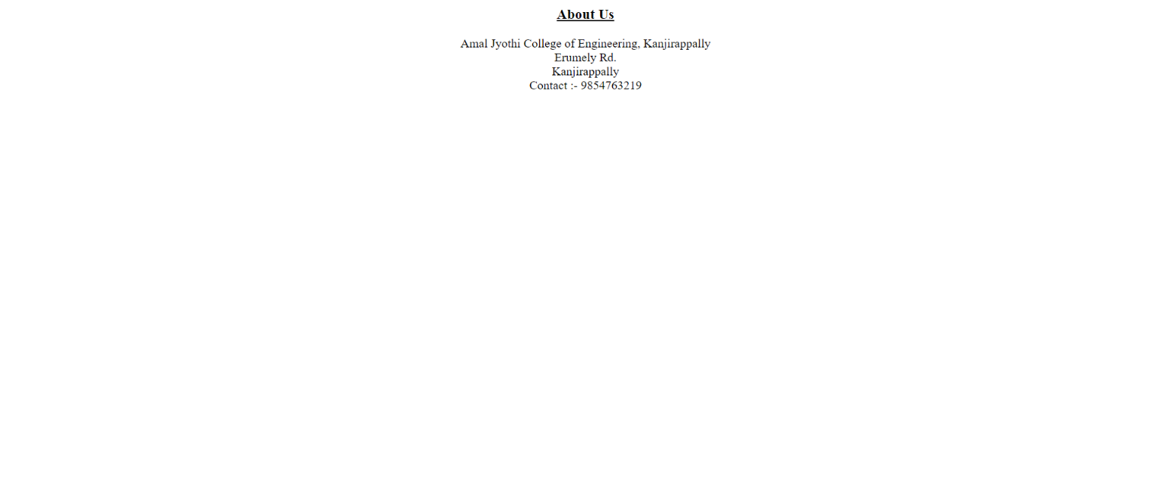

**Program – 3**

**Aim:-**

Design a website of your college which contain home page, department and about us using html (use image, tables and links)

**Program code**

**index.html**

<html>

<title>Homepage</title>

<body>

<center><h1>AMAL JYOTHI COLLEGE OF ENGINEERING</h1></center>

<img src="clg.jpg"><br>

<a href="department.html">MCA Department</a><br><br>

<a href="aboutus.html">About us</a>

</body>

</html>

**department.html**

<html>

<title>MCA</title>

<body>

<b>MCA department info</b><br>

<table border="1">

<tr>

<th>Name</th>

<th>Position</th>

</tr>

<tr>

<td>Fr. Rubin</td>

<td>HOD</td>

</tr>

<tr>

<td>Dr. Manju</td>

<td>Assistant Professor</td>

</tr>

</table>

</body>

</html>

**aboutus.html**

<html>

<title>About Us</title>

<body>

<center><h3><u>About Us</u></h3>

Amal Jyothi College of Engineering, Kanjirappally<br>

Erumely Rd.<br>

Kanjirappally<br>

Contact :- 9854763219</center>

</body>

</html>

**Output**

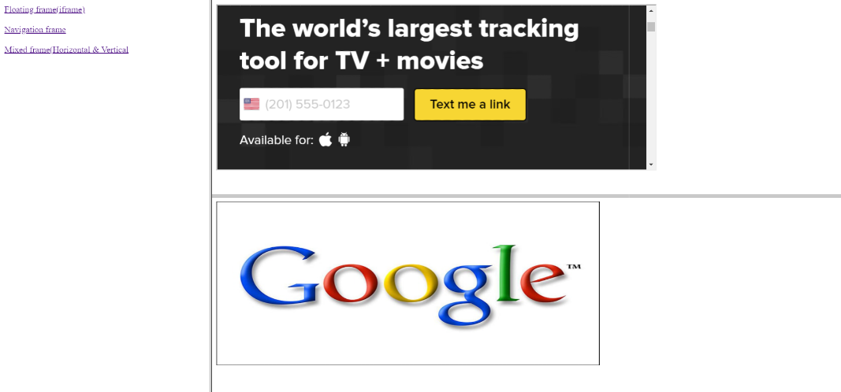

**Program – 4**

**Aim:-**

Create a HTML page with different types of frames such as floating frame(iframe), navigation frame & mixed frame (horizontal and vertical)

**Program code**

**index.html**

<html>

<frameset cols="25%,*">

<frame src="colside.html"></frame>

<frameset rows="50%,*">

<frame src="iframe.html"></frame>

<frame src="rowside2.html"></frame>

</frameset>

</frameset>

</html>

**colside.html**

<html>

<body>

<a href="#">Floating frame(iframe)</a><br><br>

<a href="#">Navigation frame</a><br><br>

<a href="#">Mixed frame(Horizontal & Vertical</a>

</body>

</html>

**iframe.html**

<html>

<body>

<iframe src="https://www.tvtime.com/" width="800" height="300"></iframe>

</body>

</html>

**rowside2.html**

<html>

<body>

<img src="google.jpg" height="300" width="700">

</body>

</html>

**Output**

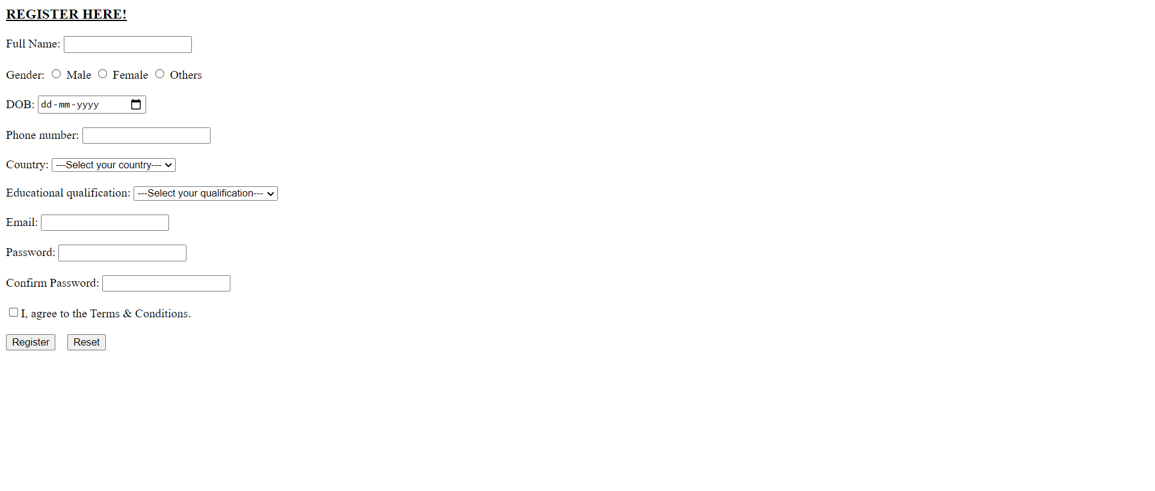

**Program – 5**

**Aim:-**

Demonstrate a registration form using HTML.

**Program code**

<html>

<body>

<h3><u>REGISTER HERE!</u></h3>

<form>

Full Name: <input type="text"><br><br>

Gender: <input type="radio"> Male <input type="radio"> Female <input type="radio"> Others<br><br>

DOB: <input type="date"><br><br>

Phone number: <input type="number"><br><br>

Country: <select>

<option>---Select your country---</option>

<option>India</option>

<option>China</option>

<option>Pakistan</option>

<option>England</option>

</select><br><br>

Educational qualification: <select>

<option>---Select your qualification---</option>

<option>Under Graduate</option>

<option>Post Graduate</option>

<option>PhD</option>

<option>Others</option>

</select><br><br>

Email: <input type="text"><br><br>

Password: <input type="password"><br><br>

Confirm Password: <input type="password"><br><br>

<input type="checkbox">I, agree to the Terms & Conditions.<br><br>

<input type="submit" value="Register">&emsp;<input type="reset">

</form>

</body>

</html>

**Output**

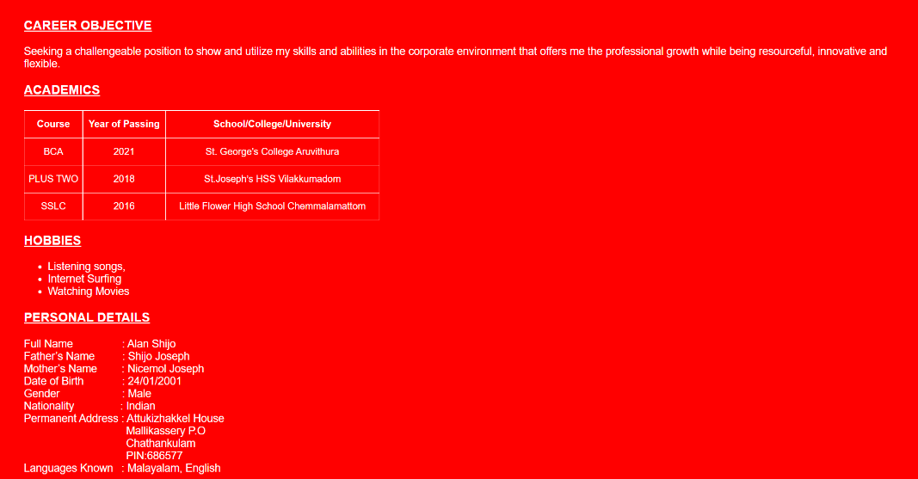

**Program – 6**

**Aim:-**

Design your biodata by applying CSS.

**Program code**

**index.html**

<html>

<head>

<title>Curriculum vitae</title>

<link rel="stylesheet" href="mystyle.css">

</head>

<style>

table, td, th{

border: 1px solid white;

border-collapse: collapse;

text-align: center;

}

</style>

<body>

<h3>career objective</h3>

Seeking a challengeable position to show and utilize my skills and abilities in the corporate environment that offers me the professional growth while being resourceful, innovative and flexible.

<h3>academics</h3>

<table style="width: 40%; height: 30%;">

<tr>

<th>Course</th>

<th>Year of Passing</th>

<th>School/College/University</th>

</tr>

<tr>

<td>BCA</td>

<td>2021</td>

<td>St. George's College Aruvithura</td>

</tr>

<tr>

<td>PLUS TWO</td>

<td>2018</td>

<td>St.Joseph’s HSS Vilakkumadom</td>

</tr>

<tr>

<td>SSLC</td>

<td>2016</td>

<td>Little Flower High School Chemmalamattom</td>

</tr>

</table>

<h3>Hobbies</h3>

<ul>

<li>Listening songs,</li>

<li>Internet Surfing</li>

<li>Watching Movies</li>

</ul>

<h3>personal details</h3>

Full Name &emsp;&emsp;&emsp;&emsp;&nbsp;: Alan Shijo<br>

Father’s Name &emsp;&emsp;&nbsp;: Shijo Joseph<br>

Mother’s Name &emsp;&emsp;: Nicemol Joseph<br>

Date of Birth &emsp;&emsp;&emsp;&nbsp;: 24/01/2001<br>

Gender &emsp;&emsp;&emsp;&emsp;&emsp;&ensp;: Male<br>

Nationality &emsp;&emsp;&emsp;&emsp;: Indian<br>

Permanent Address : Attukizhakkel House<br>

&emsp;&emsp;&emsp;&emsp;&emsp;&emsp;&emsp;&emsp;&emsp;&ensp;Mallikassery P.O<br>

&emsp;&emsp;&emsp;&emsp;&emsp;&emsp;&emsp;&emsp;&emsp;&ensp;Chathankulam<br>

&emsp;&emsp;&emsp;&emsp;&emsp;&emsp;&emsp;&emsp;&emsp;&ensp;PIN:686577<br>

Languages Known &ensp;: Malayalam, English

</body>

</html>

**mystyle.css**

*{

font-family: sans-serif;

color: white;

}

h3{

text-decoration: underline;

text-transform: uppercase;

}

body{

background-color: red;

margin-left: 40px;

margin-top: 30px;

font-size: 18px;

}